In the below screen, please add an option for new tenant to go to registration screen.
add link under sign In button,
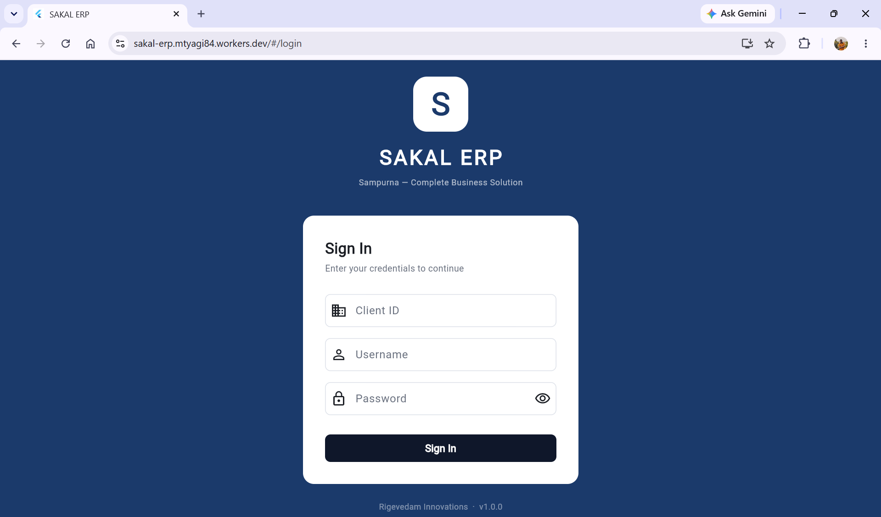

Country should have List of values.
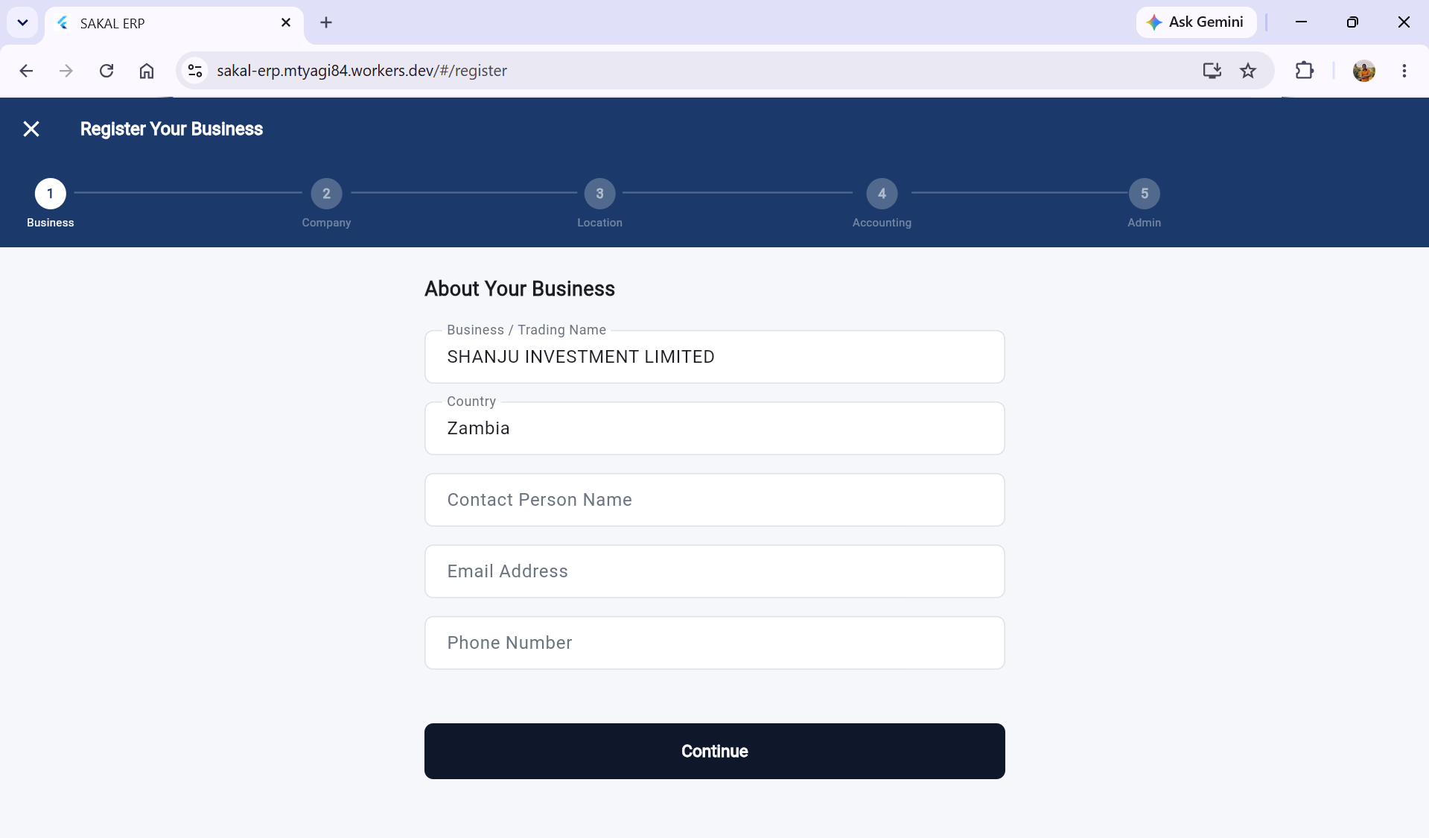

Currency is not showing all values .. in registration page all currency should be shown,
and it should be searchable. Currently it is very difficult to look for specific currency,.
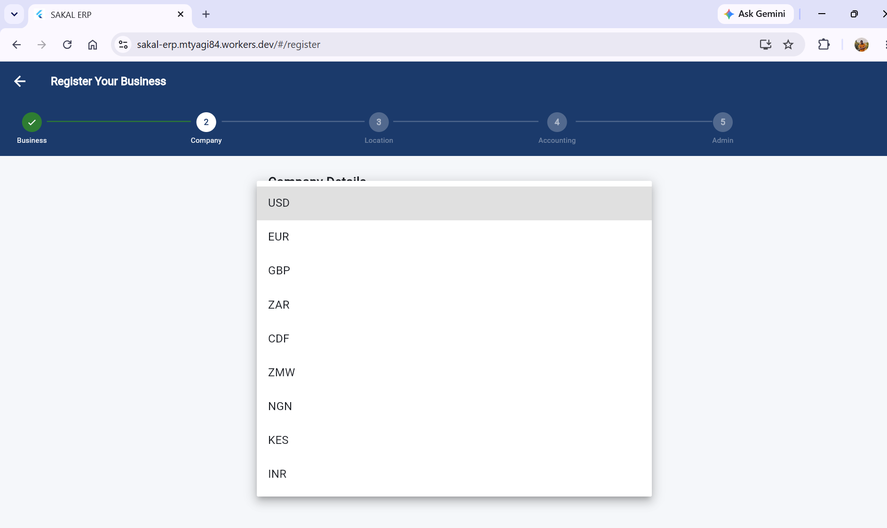

While registering Admin account, by default Admin should have all action check bock tick (Add, Edit, View , Excel excel)
I noticed, all button access is there except Add.
I give manually.


